**Compaction job Failure**

These links gives the compaction jobs airflow jobs

Genie jobs :- <https://genie-ingestion.predixdatafabric.com/jobs>

airflow :- <https://airflow-ingestion.predixdatafabric.com/admin/>

* these are the compaction Airflow’s

cid:image001.jpg@01D88B07.F795EF20

* auroracompaction_kpi :-
* DAG’s

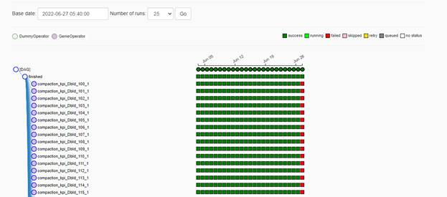

Here

Error marked in yellow colour

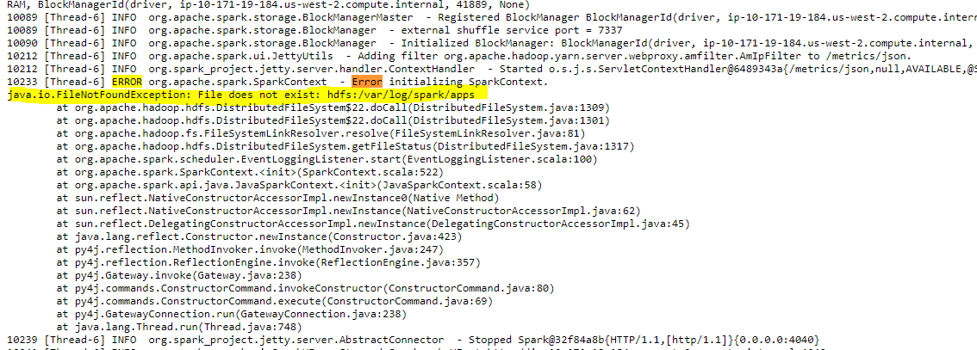

As per the highlighted comments there is a missing folder “Spark” in the Hadoop file system where the compaction jobs run needs that folder as a directory to run the tasks and show the jobs

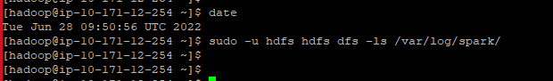

Need to create the spark folder for the

